BHARTI KUMARI SAW
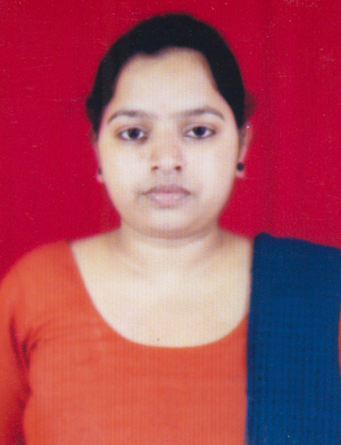
+91-8986836345
guptabharti185@gmail.com

CAREER OBJECTIVE: To build a career in industrial Automation with a leading industrial Automation firm by excelling as a self motivator with strong character and competitive spirit. And to work with commitment and passion in an organization focused on excellence and gain experience. Looking for an opportunity in your organization where I can use my considerable expertise in engineering to find a platform to contribute positively to the success of your organization.

EDUCATIONAL QUALIFICATION
- Pursuing B.TECH from KISD under BPUT in branch ETC, with current CGPA 7.2passing out in academic session 2013-2017
- Completed 12th from D.A.V PUBLIC SCHOOL,ALKUSA,DHANBAD under CBSE board in the year 2012 with 68%
- Completed 10th from D.A.V PUBLIC SCHOOL,ALKUSA,DHANBAD under CBSE board in the year 2010 with 70.3 %

TECHNICAL CERTIFICATION
- Vocational training from BSNL,DHANBAD 2015

TECHNICAL SKILLS
- C,C++

CO-CURRICULAR ACTIVITIES
- Seminar presentation on ONLINE DATING organized by the dept. of the college
- Participated in QUIZ Competition held during Annual tech Fest 2014
- Seminar presentation on TRACKING ISSUE IN WIRELESS SENSOR NETWORK organized by the dept. of the college.

EXTRA CURRICULAR ACTIVITIES/AREA OF INTEREST
- Painting
- Art &craft
- Cooking food

PERSONAL DETAILS
Father’s name : Ghaman saw
Mother’s name : Gayatri Devi
Permanent Address : Near electric office,karkend bazar,Dhanbad,Jharkhand,Pin-828116
Date of birth : 15th February,1994
Languages Known : English, Hindi.

DECLARATION
I hereby declare that all the information given above is true and correct to the best of my knowledge and belief.

DATE:
PLACE: Bhubaneswar SIGNATURE

